GRADE LEVEL: Kindergarten
UNIT: Limestone

Abstract:
This unit introduces students to the importance of geography on a local scale and uses the history and economics of the Indiana limestone industry to familiarize students with the importance of places. Students explore where limestone comes from, what its uses have been in the past and in the present, how limestone is transported and used to create different structures and finally describe why places and addresses are essential in understanding the community in which they live.

Focus Questions:
Where does limestone come from and how has it been used in the past/currently?
How does limestone get from a quarry to your home or to a public building?
Why is it important to know your address or where important places are?

Instructional Resources:
https://www.youtube.com/watch?v=mt5Ik0f2fXE
http://geology.com/usgs/limestone/
http://geology.com/rocks/limestone.shtml
http://www.stonefinder.com/wonder_stone/pyramid_of_egypt.html#.Vp5yxjZlxIE
http://www.lhoist.com/lime-throughout-history
http://www.indystone.com/indiana-limestone-building-construction.html
http://www.indystar.com/picture-gallery/money/companies/2014/02/27/indiana-limestone-co-has-a-history-of-monumental-buildings/5840821/

Catalog of Lessons:
Lesson 1: A Blast From the Past- The History and Uses of Limestone
Students identify where limestone comes from and analyze how it was used over the course of human history. Students examine and dated images depicting the historical usage of limestone and place them into the correct chronological order.

Lesson 2: Moving Mountains- Transporting Limestone for Practical Usage
Students explore how limestone is transported from a quarry to a building site. Students also explore modern uses for limestone and utilize play money to purchase limestone in a simulation activity.

Lesson 3: Locating Limestone- Discovering Limestone in a Local Community
Students determine which buildings in their community are important (i.e. hospitals, police station, library) and locate these buildings on a map. Students also analyze which important local buildings have limestone components and determine basic directions to each place in relation to the school.

Lesson 4: - Knowing Where Important Places Are
Students examine the importance of memorizing their home address, stamp it into a small plaster block and explain why knowing where key places such as their home, school and local hospital are important.

Benchmarks | Assessment Tasks | Concepts
Describe where limestone comes from and how it was used in the past and present. (K.1.1; K.1.3; K.3.1)  Analyze and explain how limestone is transported and used to create different structures in the community. (K.3.1; K.3.3; K.4.1)  Locate important buildings in their community that are made from limestone and determine their distance from the school. (K.3.1; K.3.3)  Explain why places and addresses are essential in understanding the community in which they live. (K.3.3; K.3.4) | Identify where limestone comes from and determine the order of historical uses of limestone by organizing numbered images. (K.1.1; K.1.3; K.3.1)  Describe how limestone gets from a quarry to a building site and elaborate on how it is used to create different structures in the community by simulating the purchase of limestone with fake money. (K.3.1; K.3.3; K.4.1)  Locate important buildings in their community such as: the school, hospital, police station, fire station on a map and determine the basic directions to each place; determine which place is the furthest/ closest to the school. (K.3.1; K.3.3)  Memorize and recite their home address, stamp it into a small plaster block and explain why knowing where places are is important. (K.3.3; K.3.4) | Community  Place  Past  Present  Directions  Distance

Assessment Task 1:
GRADE LEVEL: Kindergarten
UNIT: Limestone

Abstract
In this task, students describe where limestone comes from and how it was used in the past and present.

Prompt
In groups of 3-4, students analyze scrambled dates and images of historical limestone usage and place them in correct chronological order.

Directions
Students begin class discussing the question: What is limestone and where do you think it comes from? Why do you think humans have used it as a building material for thousands of years? Students then break off into small groups to analyze and reorder scrambled images depicting historical uses of limestone.

Procedure
Provide direct instruction concerning the source of limestone and lead students in large group analysis of a timeline depicting historical uses for limestone. Break students off into groups of 3-4 and assign groups a collection of images to place in the correct order. Students will then place their images on the class timeline and present their findings. The timeline constructed by students will be displayed at their local library.

Scoring Rubric

Benchmarks | 1 | 2 | 3 | 4
Describe where limestone comes from and how it was used in the past and present. (K.1.1; K.1.3; K.3.1) | Student does not describe where limestone comes from and contains significant errors on class timeline. | Student describes where limestone comes from and contains 2-3 errors on class timeline. | Student thoroughly describes where limestone comes from and contains one error on class timeline. | Student thoroughly describes where limestone comes from and all images are correctly ordered on class timeline.

Assessment Task 2:
GRADE LEVEL: Kindergarten
UNIT: Limestone

Abstract
In this task, students analyze and explain how limestone is transported and used to create different structures in their community.

Prompt
In groups of 3-4, students manage their own limestone quarry business, and purchase or sell limestone to other groups of classmates using play money.

Directions
After watching a video clip on how limestone is transported from quarries and repurposed into building materials, students simulate the commerce surrounding a limestone business using play money. Ask students leading questions: How do you think limestone gets from a quarry to your home? Can you think of any buildings in your community that are made with limestone?

Procedure
Provide direct instruction concerning the transportation of limestone. After viewing video clip, students break off into groups of 3-4 and travel to each station that simulates the process of limestone purchase and transfer. Afterwards, students compile their observations about the process of transferring and building within their community limestone onto a poster board, which will be displayed at their local library.

Scoring Rubric

Benchmark | 1 | 2 | 3 | 4
Analyze and explain how limestone is transported and used to create different structures in the community. (K.3.1; K.3.3; K.4.1) | Student fails to meet minimum requirements. | Student skipped or failed to complete 1 station and/or contributes 1 observation to the poster board. | Student actively engages in every station and contributes 2-3 observations to the poster board. | Student actively engages in every station and contributes 3 or more observations to the poster board.

Assessment Task 3:
GRADE LEVEL: Kindergarten
UNIT: Limestone

Abstract
In this task, students locate important buildings within their community that are made from limestone and determine their distance from their school.

Prompt
As a large group, students examine simplified maps of their community, locate their school and determine the basic directions to each place. Students also investigate pictures of local limestone structures found in their community.

Directions
Before examining a map of the community, ask students to create a list of important places (i.e. police station, hospital, library, school) and compile the list on a poster board. Engage students in large group analysis of a community map. Ask students leading questions such as: In order to visit the police station, which way do we need to go? Which side of the map is the library located on, left or right? Is the hospital located in the upper or lower part of the map? Which buildings are made from limestone? Which building made of limestone is closest to the school?

Procedure
Have students generate a list of important places and compile said list on a poster board. After engaging students in large group analysis, have each student individually locate their home on the community map and assign them a location to give simplified directions from (left, right, up, down). Also assess student’s ability to determine which communal limestone structure is closest to their place of residence on the map.

Scoring Rubric

Benchmark | 1 | 2 | 3 | 4
Locate important buildings in their community that are made from limestone and determine their distance from the school. (K.3.1; K.3.3) | Student failed to adequately determine the directions to their home on a map or did not identify the nearest communal structure made of limestone. | Student determined the directions to their home on a map and identified the nearest communal structure made of limestone with two errors. | Student determined the directions to their home on a map and identified the nearest communal structure made of limestone with one error. | Student accurately determined the directions to their home on a map and identified the nearest communal structure made of limestone.

Assessment Task 4:
GRADE LEVEL: Kindergarten
UNIT: Limestone

Abstract
In this task, students analyze and determine why places and addresses are essential in order to understand the community in which they live.

Prompt
Individually, students shall memorize their home address, explain why it is important and carve it onto a small block of plaster of Paris

Directions
Lead large group discussion and ask students leading questions: Why is it important to memorize your home address? Why is it valuable to know where important places are located by their address? What can be an easy way to help you remember your address or the addresses of important places?

Procedure
Lead students in large group discussion then, break them off into small groups. Instruct students to travel to teach station to mix and pour their plaster blocks into molds. At the final station, ask students to recite their address and to engrave it into their piece of semi-dried plaster.

Scoring Rubric

Benchmark | 1 | 2 | 3 | 4
Explain why places and addresses are essential in understanding the community in which they live. (K.3.3; K.3.4) | Student does not adequately explain why knowing addresses is important and recalls their address both verbally and written with more than two errors. | Student explains why knowing addresses is important and recalls their address both verbally and written with 2 errors. | Student thoroughly explains why knowing addresses is important and recalls their address both verbally and written with one error. | Student thoroughly explains why knowing addresses is important and recalls their address both verbally and written with no errors.

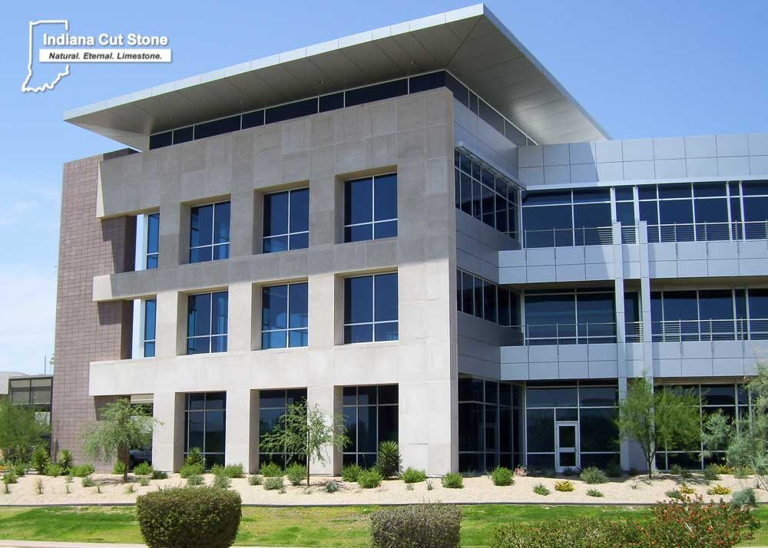
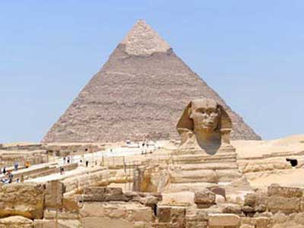
Lesson 1 Handout Examples:

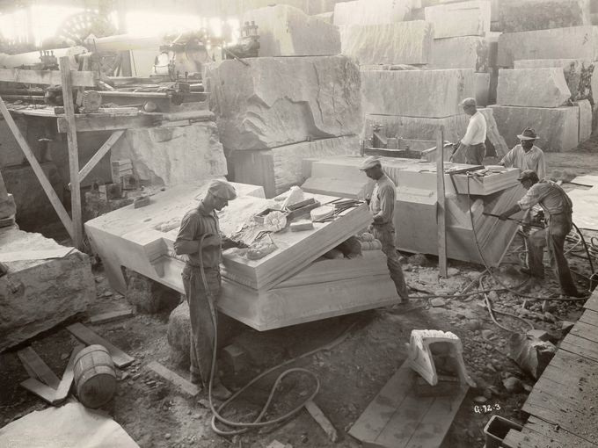

Directions:

Carefully cut out each picture and place them in order on the class time line. Be sure to explain why you chose to order them the way you did!

Lesson 3 Handout Examples:

Oh the Places You’ll Go!

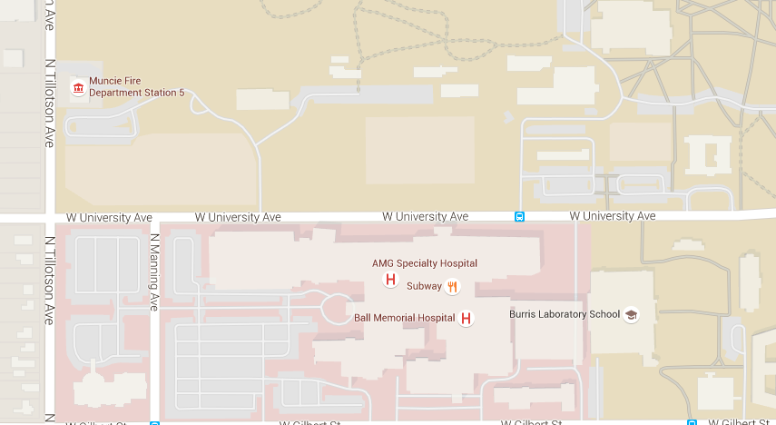

Your school is located here

Which way would you go to get to the fire station? How about the hospital?

