COURSE TITLE: American History
GRADE LEVEL: Sixth Grade
UNIT: Limestone

Abstract: This unit introduces students to deep historical analysis methods. Over the course of history, humans used limestone to construct physical structures to assert political authority, signify important cultural values, or to even unify communities socially. Students examine examples of how communities across the globe used limestone for these purposes and complete a big little history on an important limestone structure in the state of Indiana of their choosing.

Focus Questions:
1. How did the Egyptians use limestone structures to assert political authority and control?
2. How did the French use limestone to physically construct Reims Cathedral and socially construct important cultural values?
3. How did the limestone Indianapolis Soldiers’ and Sailors’ Monument unify our state and commemorate military service after the Civil War?

Benchmarks | Assessment Tasks | Key Concepts
Compare and contrast how limestone structures have been used to assert or symbolize political authority in both the past and present and evaluate how these structures altered the environment. (6.1.1; 6.1.18; 6.1.23; 6.2.1; 6.3.4; 6.3.10; 6.3.11; 6.3.13)  Analyze how limestone structures have been used to communicate cultural values such as laws, religion, or places of communal importance across the globe. (6.1.2; 6.1.4; 6.1.20; 6.3.4; 6.3.10; 6.3.13)  Examine how limestone memorials unify and divide communities after conflict (6.1.2; 6.1.4; 6.1.20; 6.3.4; 6.3.10; 6.3.13)  Research a limestone structure in Indiana and articulate its historical, social, political and environmental significance. (6.1.18; 6.1.20; 6.1.22; 6.1.23; 6.2.7; 6.3.10; 6.3.11; 6.3.13) | Create a poster board that compares and contrasts how modern limestone structures in our nation’s capital assert or symbolize political authority with one from a classical civilization. (6.1.1; 6.1.18; 6.1.23; 6.2.1; 6.3.4; 6.3.10; 6.3.11; 6.3.13)  Research the social and cultural significance of an assigned limestone war memorial in groups and orally present findings with the class. (6.1.2; 6.1.4; 6.1.20; 6.3.4; 6.3.10; 6.3.13)  Research a limestone structure in Indiana and articulate its historical, social, political and environmental significance in an essay. (6.1.18; 6.1.20; 6.1.22; 6.1.23; 6.2.7; 6.3.10; 6.3.11; 6.3.13) | Community  Symbol  Culture  Unity  Coercion  Values

Instructional Resources
http://www.reims-cathedral.culture.fr/materials.html

http://sciencelearn.org.nz/Contexts/A-Fizzy-Rock/Timeline

Maps of Time- David Christian

Deep History: The Architecture of Past and Present- Andrew Shryock & Daniel Lord Smail
http://www.history.com/shows/big-history/season-1/episode-5

www.thebighistoryproject.com

Catalog of Lessons

Lesson 1: Using Limestone to Structure People
In this two day lesson, students compare and contrast how limestone structures have been used to assert or symbolize political authority in both the past and present and evaluate how these structures altered the environment. Students watch episode five of Big History and work in groups to create a poster board that compares and contrasts how modern limestone structures in our nation’s capital assert or symbolize political authority with one from a classical civilization.

Lesson 2: Using Limestone to Communicate Culture
In this lesson, students analyze how limestone structures have been used to communicate cultural values such as laws, religion, or places of communal importance across the globe. Students analyze primary source images of limestone structures with cultural significance and, as a class, discuss how such structures are used to communicate cultural ideas.

Lesson 3: Limestone as a Binder of People
Students continue building on knowledge established in the previous lesson and examine how limestone memorials unify and divide communities after times of conflict. After engaging in a large group discussion concerning the controversy surrounding Confederate and Civil Rights Movement memorials, students research the social and cultural significance of an assigned limestone war memorial in groups and orally present their findings with the class.

Lesson 4: Little Big History of Limestone in Indiana
For the final lesson of the unit, students conduct independent research of a limestone structure in Indiana and articulate its historical, social, political and environmental significance in a Little Big History essay.
Assessment Task 1:
GRADE LEVEL: Sixth Grade
UNIT: Limestone
Abstract
In this task, students compare and contrast how limestone structures have been used to assert or symbolize political authority in both the past and present and evaluate how these structures altered the environment.

Prompt
In groups of 3-4, students create a poster board that compares and contrasts how modern limestone structures in our nation’s capital assert or symbolize political authority with one from a classical civilization.

Directions
Students begin class discussing the following questions: What does the White House represent to Americans? Can anyone think of a structure in other parts of the world that serve a similar purpose? Why might governments utilize slave labor to construct large political structures- what message does it communicate to people living in that particular civilization? How did the Egyptians use limestone structures to assert political authority and control? Students then watch the Episode Five of H2’s Big History and take notes concerning how rulers of ancient civilizations used coercion and cooperation to construct large structures that represented political power, as well as how these structures impacted the environment. The next day, students review their notes, break off into groups of 3-4 to create a poster board that compares and contrasts how modern limestone structures in our nation’s capital assert or symbolize political authority with one from a classical civilization.

Procedure
Lead students in large group discussion and assist them as they take notes while they watch Big History. On day two, break students off into groups of 3-4 and provide them with time to research, compare and contrast modern limestone political structures with ancient ones. Students then create poster board and present their findings to the class. The poster board constructed by students will be displayed at their local library.

Scoring Rubric
Benchmark | 1 | 2 | 3 | 4
Compare and contrast how limestone structures have been used to assert or symbolize political authority in both the past and present and evaluate how these structures altered the environment. (6.1.1; 6.1.18; 6.1.23; 6.2.1; 6.3.4; 6.3.10; 6.3.11; 6.3.13) | Student does not adequately compare and contrast limestone structures and the way they altered the environment; may lack an entire section. | Student provides 3 comparisons or contrasts of limestone structures and 2 ways these structures altered the environment | Student provides 4 comparisons or contrasts of limestone structures and 3-4 ways these structures altered the environment. | Student provides 5 or more comparisons or contrasts of limestone structures and 5 or more ways these structures altered the environment

Assessment Task 2:
GRADE LEVEL: Sixth Grade
UNIT: Limestone
Abstract
Students continue building on knowledge established in the Lesson 2 and examine how limestone memorials unify and divide communities after times of conflict.

Prompt
After engaging in a large group discussion concerning the controversy surrounding Confederate and Civil Rights Movement memorials, students research the social and cultural significance of an assigned limestone war memorial in groups and orally present their findings with the class.

Directions
Students begin class discussing controversial questions in an anticipation guide analysis. Then, students examine a case study concerning the Indianapolis Soldiers’ and Sailors’ Monument and discuss the question: How did the limestone Indianapolis Soldiers’ and Sailors’ Monument unify our state and commemorate military service after the Civil War? Then, students break off into groups of 3-4 to research the social and cultural significance of an assigned limestone war memorial and orally present their findings with the class.

Procedure
Lead students in the anticipation guide discussion. Next, lead students briefly through the examination of a case study concerning the Indianapolis Soldiers’ and Sailors’ Monument. Break students off into groups of 3-4 and provide 15-20 minutes of time to research the social and cultural significance of an assigned limestone war memorial. Have students present their findings orally to the class. Students with exemplary oral presentations will present theirs at their local AMVETS.

Scoring Rubric
Benchmark | 1 | 2 | 3 | 4
Research the social and cultural significance of an assigned limestone war memorial in groups and orally present findings with the class. (6.1.2; 6.1.4; 6.1.20; 6.3.4; 6.3.10; 6.3.13) | Student does not meet minimum requirement of analysis and/or fails to provide examples of their assigned memorial’s cultural significance. | Student’s lacks analysis of cultural significance of assigned memorial and provides 3 examples of its cultural significance. | Student’s analysis of cultural significance of assigned memorial is thorough and provides 4 examples of its cultural significance. | Student’s analysis of cultural significance of assigned memorial is exceptional and provides 5 or more examples of its cultural significance.

Assessment Task 3:
GRADE LEVEL: Sixth Grade
UNIT: Limestone
Abstract
For this task, students research a limestone structure in Indiana and articulate its historical, social, political and environmental significance and write a Little Big History essay.

Prompt
After reviewing the unit, students work independently to research and construct their essays over the span of two lessons.

Directions
Students work independently in the computer lab to research and write their outline drafts.

Procedure
Provide students with a class period to research their limestone structure in Indiana and prewriting. The following day, provide students with the class period to write their essays and exchange with a partner to discuss their findings.

Scoring Rubric
Benchmark | 1 | 2 | 3 | 4
Research a limestone structure in Indiana and articulate its historical, social, political and environmental significance. (6.1.18; 6.1.20; 6.1.22; 6.1.23; 6.2.7; 6.3.10; 6.3.11; 6.3.130 | Student does not meet minimum requirements, may lack more than one analysis section. | Student’s essay may include an unclear introduction, thesis, body or conclusion. Essay includes an examination of structure’s historical, social, political and environmental significance. | Student’s essay includes a clear introduction, thesis, body and conclusion. Essay includes thorough examination of structure’s historical, social, political and environmental significance. | Student’s essay includes a clear introduction, thesis, body and conclusion. Essay includes an exceptionally thorough examination of structure’s historical, social, political and environmental significance.

Lesson 1 Handout Example:

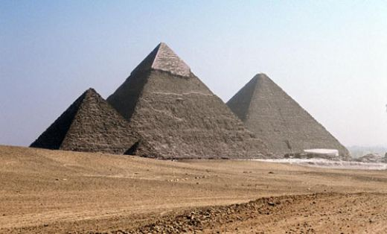
Compare and Contrast Analysis
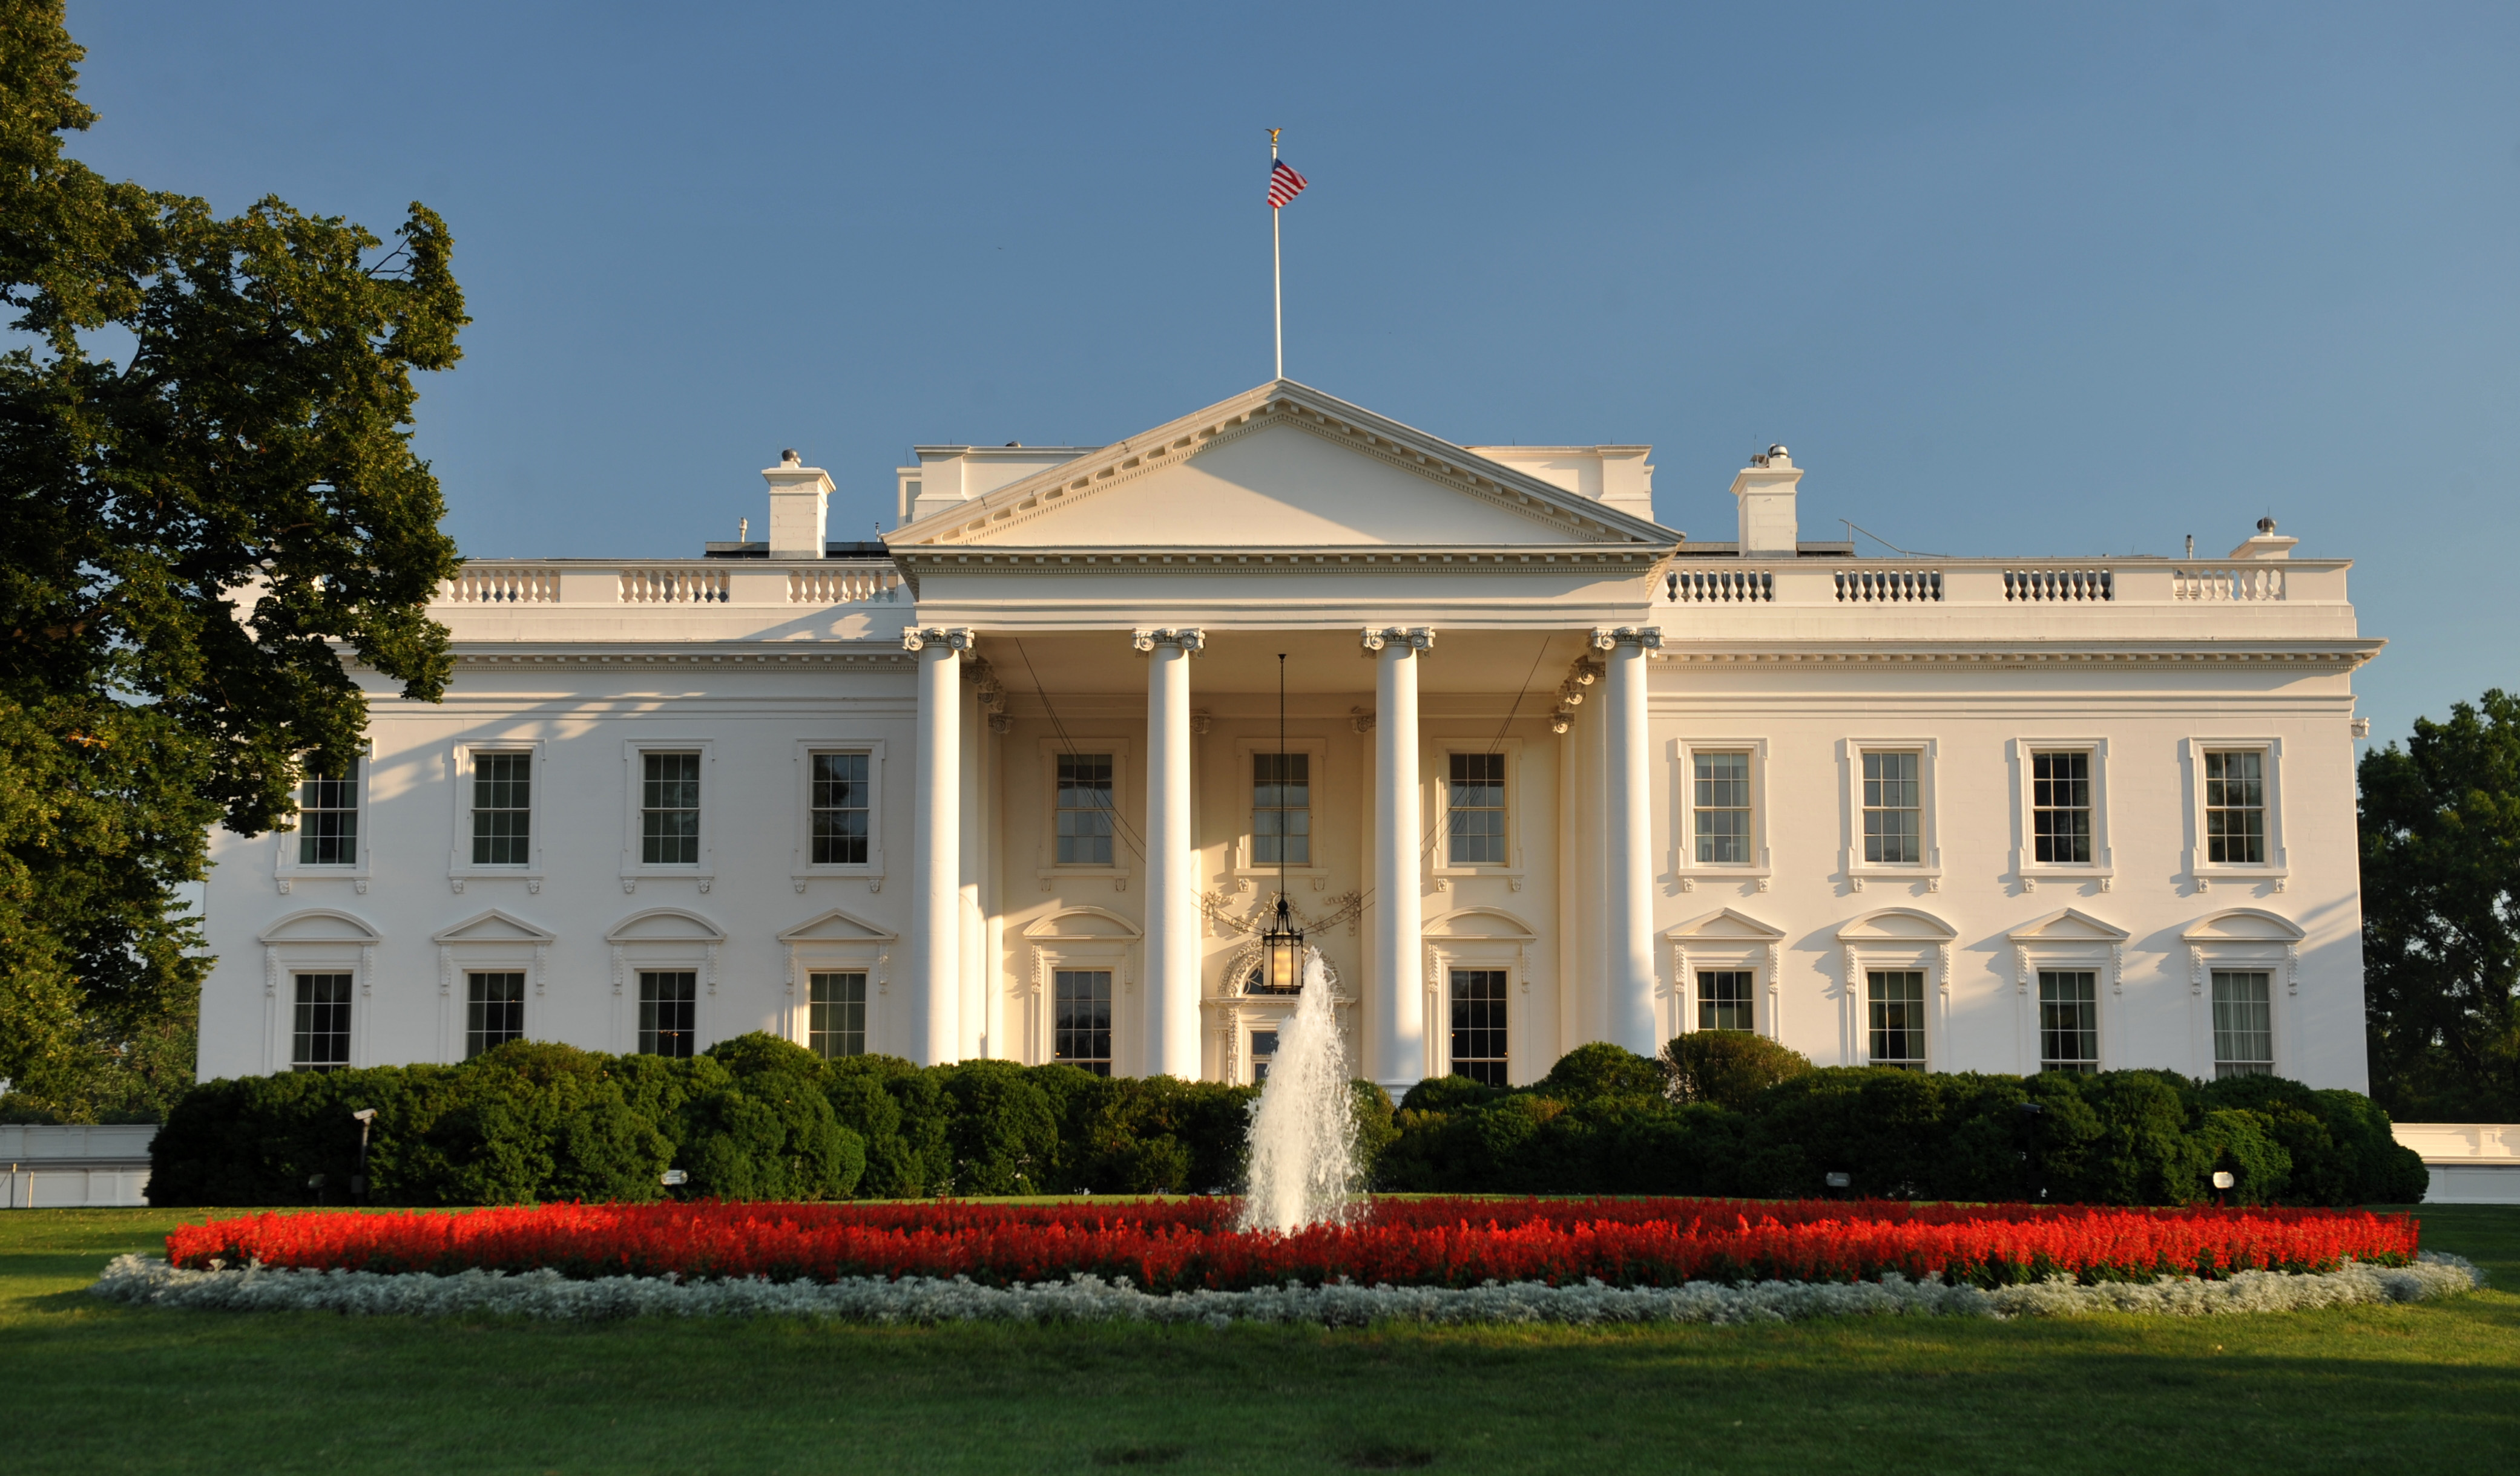
2
1

1. Identify the name of the structure in Figure 1 and determine its location.

2. Identify the name of the structure in Figure 2 and determine its location.

3. What does structure in Figure 1 represent to Americans; what purpose does it serve and what does it symbolize?

4. What is the purpose of the structure in Figure 2 and what might it have symbolized to the people who constructed it?

5. Both structures are made of limestone and were built using slave labor. What does the use of slave labor in construction communicate to people living in that particular civilization during the time period of construction?

6. How do these limestone structures help leaders assert political authority or control?

Lesson 2 Handout Example:

Primary Source Image Analysis and Brief Response

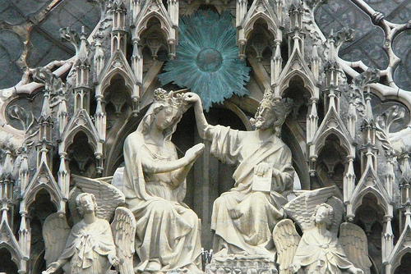
Reims Cathedral, France (constructed 1211, opened 1275)

Analyze the following image and consider the following questions in order to frame your one paragraph response: What cultural ideas are being communicated in this limestone structure? What does it reveal about the beliefs held by French people during the 1200s? What else is happening in Europe during the time period that supports your assertion?
________________________________________________________________________________________________________________________________________________
________________________________________________________________________
________________________________________________________________________
________________________________________________________________________
________________________________________________________________________
________________________________________________________________________________________________________________________________________________________________________________________________________________________________________________________________________________________________

Lesson 3 Handout Example:

Anticipation Guide
‘
Do you believe that…

1. The US government should remove statues of Confederate soldiers or leaders from the Civil War?

Yes No Explain:

2. The US government should replace Confederate memorials with Union or Civil Rights Movement monuments?

Yes No Explain:

3. Memorials help unify and heal communities after war?

Yes No Explain:

4. War memorials are too costly and unnecessary?

Yes No Explain:

