COURSE TITLE: American History
GRADE LEVEL: Fifth Grade
UNIT: Limestone

Abstract:
This unit explores how limestone was used in early American history. From agriculture to architecture, colonists utilized limestone as a resource to beautify their surroundings, as well as sustain their lifestyle. In this unit, students examine how Colonial Era architects used limestone to construct the White House, how upper-class colonists used it to beautify their interiors and how pioneers used it to fertilize their crops.

Focus Questions:
1. Why was limestone used to construct the White House?
2. How did life differ between wealthy colonists and pioneers?
3. How did American colonists use limestone indoors and out?
4. How was limestone useful for pioneers living on farm?
Benchmarks | Assessment Tasks | Key Concepts
Analyze why limestone was used to construct important government buildings during the Colonial Period, such as the White House, and identify why classical architecture was utilized. (5.3.12; 5.4.4; 5.1.20; 5.1.21; 5.1.22)  Analyze and describe how wealthy colonists used limestone to beautify the interiors of their homes and describe their lifestyle. (5.1.4; 5.1.7; 5.1.20; 5.1.21; 5.1.22)  Analyze how Indigenous groups lived and farmed in the Colonies and examine how colonists adopted their methods in order to survive the harsh environment of the frontier. (5.1.3; 5.1.6; 5.1.20; 5.1.21; 5.1.22; 5.3.4; 5.3.7; 5.3.10; 5.3.11)  Examine the lifestyle of pioneers and describe how they used limestone as an agricultural tool. (5.1.4; 5.1.7; 5.1.20; 5.1.21; 5.1.22; 5.3.11; 5.4.4) | Research classical architecture and create a poster board that identifies the reasons why political leaders modeled limestone government buildings after classical ones. (5.3.12; 5.4.4; 5.1.20; 5.1.21; 5.1.22)  Conduct research concerning an aspect of Thomas Jefferson’s life (slave ownership, construction of Monticello, botany or political influence) and write an essay that examines his significance as a historical figure. (5.1.4; 5.1.7; 5.1.20; 5.1.21; 5.1.22)  Locate major Native American and colonial settlements on maps, determine which natural resources in the area attracted both groups and explain why reliance or overuse of resources led to physical conflict. (5.1.3; 5.1.6; 5.1.20; 5.1.21; 5.1.22; 5.3.4; 5.3.7; 5.3.10; 5.3.11)  Write a series of journal entries from the perspective of a pioneer farmer using primary source knowledge established in class. (5.1.4; 5.1.7; 5.1.20; 5.1.21; 5.1.22; 5.3.11; 5.4.4) | Agriculture  Architecture  Conflict  Culture  Symbolism  Lifestyle

Instructional Resources
https://www.monticello.org/site/research-and-collections/limestone-land
http://explorer.monticello.org
https://www.monticello.org/site/house-and-gardens/house-image-gallery
http://www.frontiermuseum.org/exhibits/1740s-american-settlement/
http://www.frontiermuseum.org/exhibits/1700s-american-indian-hamlet/
https://catalog.libraries.wm.edu/Record/3267503
https://catalog.libraries.wm.edu/Record/1953585
http://study.com/academy/lesson/13-colonies-colonial-life-economics-politics.html
http://www.smithsonianmag.com/history/the-shocking-savagery-of-americas-early-history-22739301/?device=ipad&c=y&story=fullstory&page=2
http://www.virtualjamestown.org/page2.html
http://www.nps.gov/jame/learn/historyculture/tobacco-colonial-cultivation-methods.htm
http://www.nps.gov/jame/learn/historyculture/flax-production-in-the-seventeenth-century.htm
http://www.history.org/Almanack/life/index.cfm
America’s Women: 400 Years of Dolls, Drudges, Helpmates and Heroines by Gail Collins

Catalog of Lessons

Lesson 1: Political and Stone Foundations: Classical Architecture, Limestone & the White House
In this lesson, students examine the reasons why limestone was used to construct important political buildings during the Colonial Period, such as the White House, and identify why classical architecture was utilized. After completing a compare and contrast image analysis, students research classical architecture in groups of 3-4 and consider the following questions: Why did the Founding Fathers think it was important to not only model their government after Greece, but also their architecture as well? How does the White House’s Greek-inspired architecture reflect or symbolize Greek values of democracy? Students present their findings to the class in a poster board format.

Lesson 2: Life Styles of the Rich and Famous: Jefferson’s Monticello
In this two-day lesson, students continue building on knowledge established in the previous lesson concerning symbolism and explore how limestone was utilized in the interior of buildings owned by wealthy colonists. Students take a virtual tour of Monticello’s interior and identify limestone ceiling and door framing ornamentation, as well as classical architectural influence. Students then select a topic of interest and conduct research concerning an aspect of Thomas Jefferson’s life (slave ownership, construction of Monticello, botany or political influence) in order to write an essay that examines his significance as a historical figure.

Lesson 3: Simpler Ways of Living: Indigenous Lifestyle and Agriculture
In this lesson, students work together in groups to analyze how indigenous groups lived and farmed in the colonies and examine how colonists adopted their methods in order to survive the harsh environment of the frontier. After participating in an anticipation guide discussion, students use maps to locate major Native American and colonial settlements, and determine which natural resources in the area attracted both groups. Using this data, students explain why reliance or overuse of resources led to physical conflict between colonists and various Indigenous groups.

Lesson 4: - Frontier Farms: Colonial Agricultural Methods and Adaptations
For the final lesson of the unit, students examine the difficulties surrounding the harsh, rugged lifestyle of early pioneers and farmers. Students watch a video concerning lifestyles across the thirteen colonies and then investigate how pioneers used limestone and other agricultural methods to experiment with Old World, as well as New World, crops. Students write journals from the perspective of a pioneer in order to demonstrate the historical knowledge gained during class discussion.
Assessment Task 1:
GRADE LEVEL: Fifth Grade
UNIT: Limestone

Abstract
In this task, students locate major Native American and colonial settlements on maps, determine which natural resources in the area attracted both groups and explain why reliance or overuse of resources led to physical conflict.

Prompt
In groups of 3-4, students create a poster board that compares and contrasts the White House and other colonial government buildings to ones from the Classical Era and investigate how and why limestone was used to beautify these buildings.

Directions
Students begin class with a compare and contrast image analysis discussion. Then, they examine the reasons why limestone was used to construct important political buildings during the Colonial Period, such as the White House, and identify why classical architecture was utilized. Students then break off into groups to research classical architecture in groups of three to four and consider the following questions: Why did the Founding Fathers think it was important to not only model their government after Greece, but also their architecture as well? How does the White House’s Greek-inspired architecture reflect or symbolize Greek values of democracy? Students present their findings to the class in a poster board format.

Procedure
Lead students in large group discussion of analysis guide then break them off into groups to conduct research for ten to fifteen minutes. Allow students an additional fifteen minutes to complete their poster boards and have students present their findings to the class. The poster board constructed by students will be displayed at their local library.

Scoring Rubric
Benchmarks | 1 | 2 | 3 | 4
Analyze why limestone was used to construct important government buildings during the Colonial Period, such as the White House, and identify why classical architecture was utilized. (5.3.12; 5.4.4; 5.1.20; 5.1.21; 5.1.22) | Student does not adequately compare and contrast limestone structures and does not explain both why colonists used limestone or classical architecture. | Student provides 3 comparisons or contrasts of limestone structures but fails to explain why colonists used limestone or classical architecture. | Student provides 4 comparisons or contrasts of limestone structures and adequately explains why colonists used limestone & classical architecture. | Student provides 5 or more comparisons or contrasts of limestone structures and thoroughly explains why colonists used limestone & classical architecture.

Assessment Task 2:
GRADE LEVEL: Fifth Grade
UNIT: Limestone

Abstract
In Task 2, students conduct research concerning an aspect of Thomas Jefferson’s life (slave ownership, construction of Monticello, botany or political influence) and write an essay that examines his significance as a historical figure.

Prompt
In this two-day lesson, students continue building on knowledge established in the previous lesson concerning symbolism and explore how limestone was utilized in the interior of buildings owned by wealthy colonists. First, students take a virtual tour of Monticello’s interior and identify limestone ceiling and door framing ornamentation, as well as classical architectural influence. Students also learn how Monticello was constructed using slave labor and other key construction details. Students then select a topic of interest and conduct research concerning an aspect of Thomas Jefferson’s life (slave ownership, construction of Monticello, botany or political influence) and spend the rest of the lesson researching on computers. The next day, students use their research to write an essay that examines Jefferson’s significance as a historical figure in related to one of the topics listed previously.

Directions
Students begin class taking a virtual tour of Monticello and identifying limestone facades. After providing brief direct instruction concerning Monticello’s construction, assign students a topic of their choice and provide them with the rest of class time to conduct research and outlining their essays. On day two, assist students as they compose their essays and have students trade their finished essays with classmates to discuss their findings.

Procedure
Provide brief direct instruction concerning Monticello while students take virtual tour. Provide twenty-five to thirty minutes of time to research on day one. On day two, assist students as they write their essays and use the remaining twenty minutes of class to monitor students while they trade and discuss papers. Students will share their essays with their local historical society at a roundtable discussion.

Scoring Rubric
Benchmark | 1 | 2 | 3 | 4
Analyze and describe how wealthy colonists used limestone to beautify the interiors of their homes and describe their lifestyle. (5.1.4; 5.1.7; 5.1.20; 5.1.21; 5.1.22) | Student does not meet minimum requirements, may lack more than one analysis section. Essay is unclear and poorly organized | Student’s essay may include an unclear introduction, thesis, body or conclusion. Essay includes an examination of Thomas Jefferson’s historical significance. | Student’s essay includes a clear introduction, thesis, body and conclusion. Essay includes thorough examination Thomas Jefferson’s historical significance. | Student’s essay includes a clear introduction, thesis, body and conclusion. Essay includes an exceptionally thorough examination of Thomas Jefferson’s historical significance.

Assessment Task 3:
GRADE LEVEL: Fifth Grade
UNIT: Limestone

Abstract
For this task, students research a limestone structure in Indiana and articulate its historical, social, political and environmental significance and write a Little Big History essay.

Prompt
In this lesson, students work together in groups to analyze how Indigenous groups lived and farmed in the Colonies and examine how colonists adopted their methods in order to survive the harsh environment of the frontier. After participating in an anticipation guide discussion, students use maps to locate major Native American and colonial settlements, and determine which natural resources in the area attracted both groups. Using this data, students explain why reliance or overuse of resources led to physical conflict between colonists and various Indigenous groups.

Directions
Students work together in groups to analyze how Indigenous groups lived and farmed in the Colonies and use maps to locate settlements, resources and conflicts.

Procedure
Engage students in anticipation guide discussion. Then, break students into groups of three and four and assign each group a specific Native American nation to research such as: Powhattan; Yamasee, Cherokee and Catawba; Shawnee and Seneca; Lenape; Iroquois and Algonquin; Penacook and Abenaki; Pequot and Mohican. Instruct students to locate their assigned tribe’s settlements, nearby resources and possible areas where battles took place. Once each group as added their Indigenous group’s details on the class map, students will present the map to their local library.

Scoring Rubric
Benchmarks | 1 | 2 | 3 | 4
Analyze how Indigenous groups lived and farmed in the Colonies and examine how colonists adopted their methods in order to survive the harsh environment of the frontier. (5.1.3; 5.1.6; 5.1.20; 5.1.21; 5.1.22; 5.3.4; 5.3.7; 5.3.10; 5.3.11) | Student does not meet minimum requirements, may include historical inaccuracies or only include research concerning one aspect of Native American life in the 13 Colonies. | Student includes 8 facts about their assigned Native American tribe’s location, use of natural resources, settlement, lifestyle and conflict with pioneers. | Student includes 9 facts about their assigned Native American tribe’s location, use of natural resources, settlement, lifestyle and conflict with pioneers. | Student includes 10 or more facts about their assigned Native American tribe’s location, use of natural resources, settlement, lifestyle and conflict with pioneers.

Assessment Task 4:
GRADE LEVEL: Fifth Grade
UNIT: Limestone

Abstract
For this task, students write a series of journal entries from the perspective of a pioneer farmer using primary source knowledge established in class.

Prompt
Students examine the difficulties surrounding the harsh lifestyle of early pioneers and farmers. Students watch a video concerning lifestyles across the thirteen colonies and then investigate how pioneers used limestone and other agricultural methods to experiment with Old and New World crops.

Directions
Play video clip for students and guide their discussing asking questions: How was life for a pioneer farmer in Virginia similar or different to that of a wealthy Colonist in New England? What types of crops did farmers rely on in the Colonies and why did farmers grow different types of crops in different areas? Which of these crops are from the New or Old World? Why was pioneer life so difficult during the time period- what hardships do you think pioneers faced? Farmers made limestone into lye as fertilizer for crops, how did wealthy colonists use limestone and why do you think pioneers did not use it in the same way?

Procedure
Lead students through discussion of video clip then provide brief direct instruction concerning the use of lye as fertilizer for crops. Then, provide thirty to thirty-five minutes of class time for students to write their pioneer journal entries. Have students spend the remaining time of class trading their journals and sharing their ‘experiences’.

Scoring Rubric
Benchmark | 1 | 2 | 3 | 4
Examine the lifestyle of pioneers and describe how they used limestone as an agricultural tool. (5.1.4; 5.1.7; 5.1.20; 5.1.21; 5.1.22; 5.3.11; 5.4.4) | Student does not meet minimum requirements, may include substantial historical inaccuracies or anachronisms. | Student’s journal includes 3 facts about life as a pioneer in the 13 Colonies; may contain inaccuracies or anachronisms. | Student’s journal includes 4 facts about life as a pioneer in the 13 Colonies; contains no inaccuracies or anachronisms. | Student’s journal includes 5 or more facts about life as a pioneer in the 13 Colonies.

Lesson 1 Handout Example:

Compare and Contrast Analysis
1
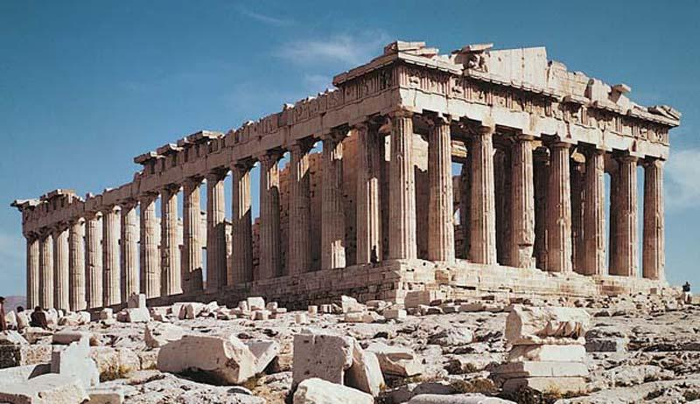
2

- Identify the name of the structure in Figure 1 and determine its location.

2. Identify the name of the structure in Figure 2 and determine its location.

3. What does structure in Figure 1 represent to Americans; what purpose does it serve and what does it symbolize?

4. How are the structures similar?

5. How are the structures different?

6. Which structure is older and how can you tell?

Lesson 2 Handout Example:

Primary Source Image Analysis

Directions: Analyze the following images from Monticello and circle evidence of

limestone usage both indoors and outdoors.

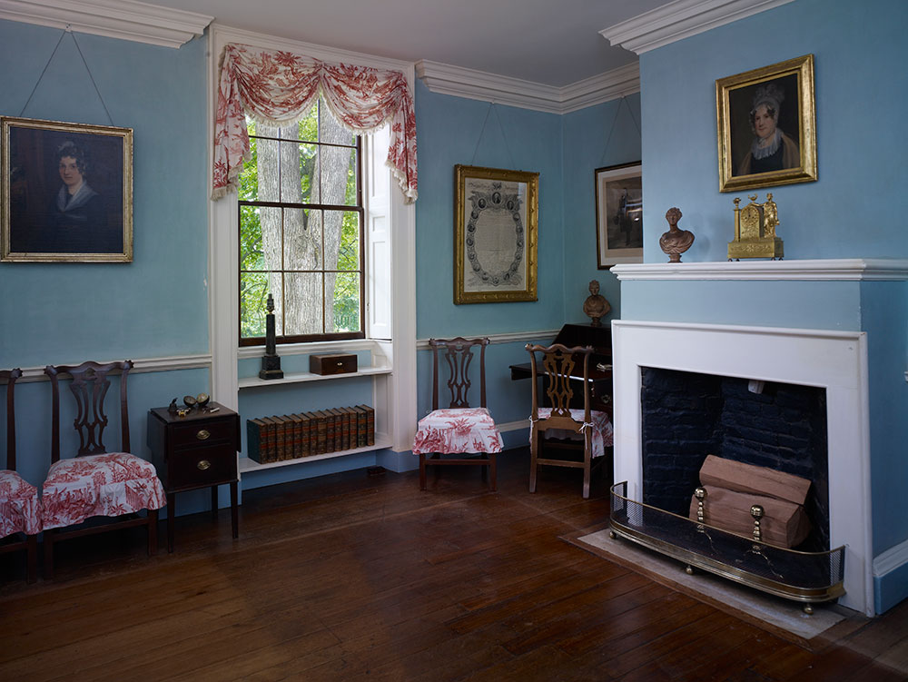
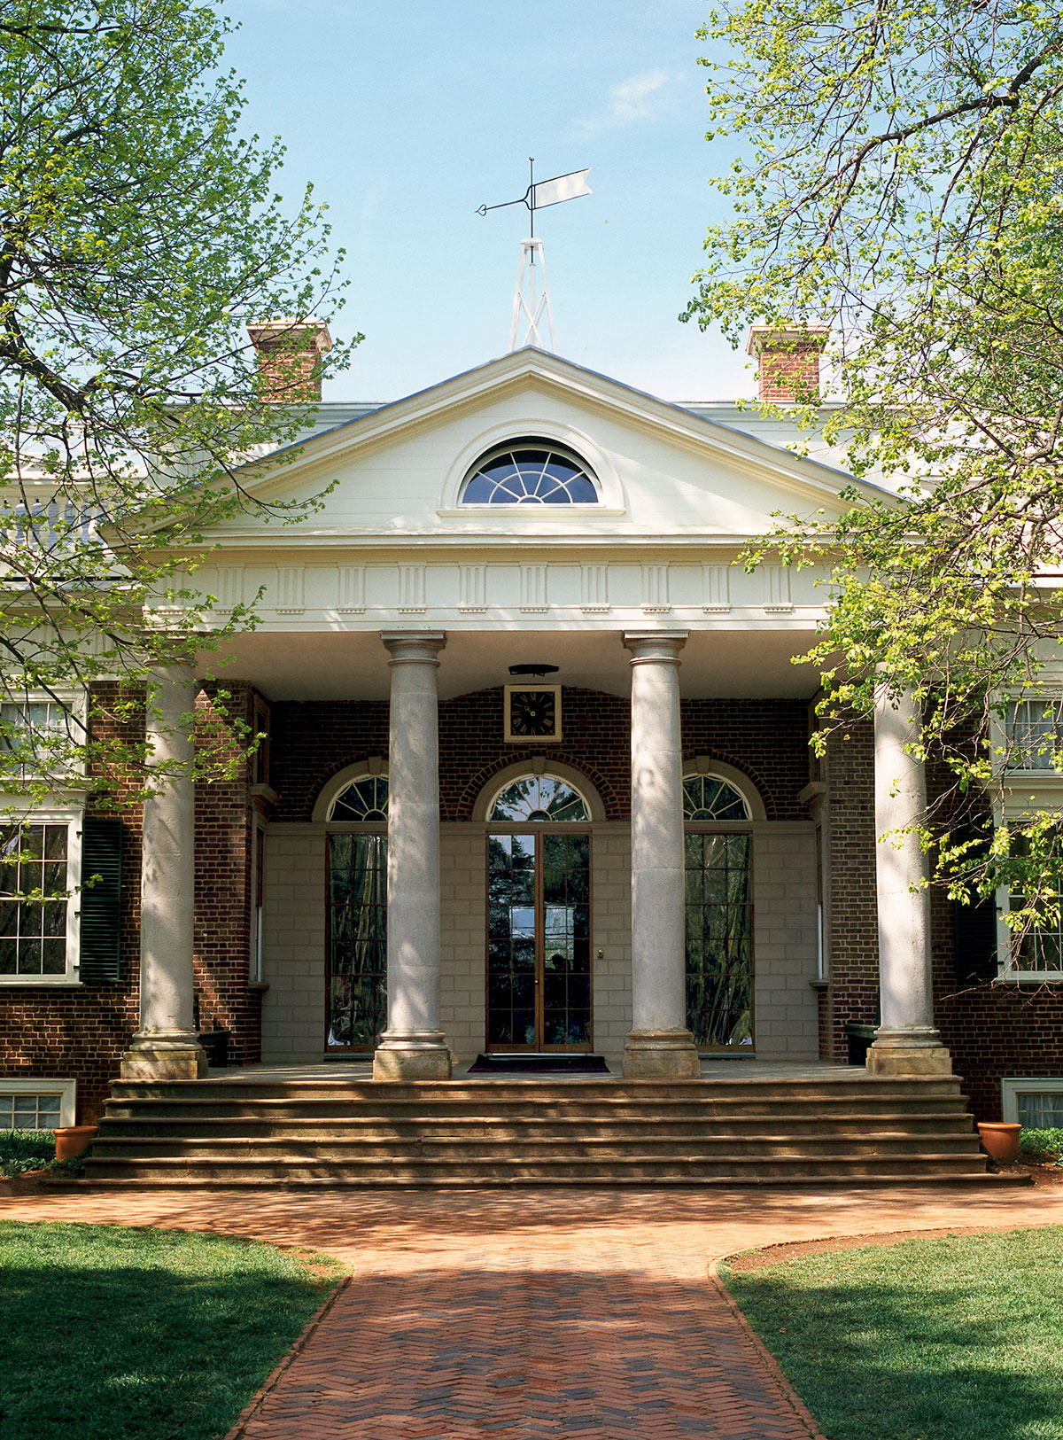

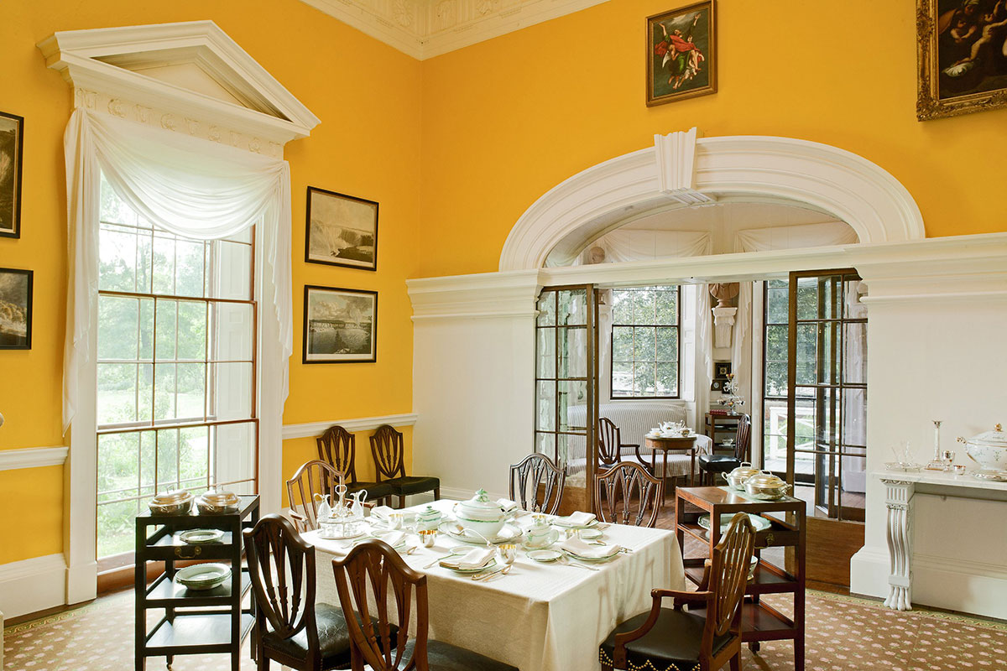

Lesson 2 Primary Source Handout Example:

Excerpts Taken From the Account Books of Thomas Jefferson:

March 29, 1771

"...purchased of Robert Sharpe one acre of limestone land on Plumb tree branch otherways called Scale's creek to be laid off as I please. under these restrictions. I am not to enter his fense on the South side of the road, nor to include his spring on the N. side of the road. I give him 40/3 for it. Watt Mousley present at making the bargain."

1. What did Jefferson purchase on March 29, 1771?

2. What does Jefferson intend to use his purchase for?

3. Why do you think Thomas Jefferson kept a record of this purchase - why would he include the price, name of the original owner and other details?

Lesson 3 Handout Example:

Anticipation Guide

Do you believe that…

- Limestone makes crops grow better?

Yes No Explain:

2. Limestone products improved the lives of the settlers?

Yes No Explain:

3. Pioneers taught Native Americans how to farm?

Yes No Explain:

4. Crops from the Old World grew easily in the 13 Colonies?

Yes No Explain:

