COURSE TITLE: Early American History
GRADE LEVEL: First Grade
UNIT: Limestone

Abstract:
This unit introduces students to the history, civics, geography, and economics relating to limestone. Students will identify continuity and change in their community due to the developments and opportunities provided by the natural resources in their area as they study the basic geographic elements of maps and globes. Throughout this limestone unit, students identify individual rights and responsibilities along with the roles of citizens and explain how goods and services are used in the community.

Focus Questions:
How is the natural resource of limestone used around the community?
What type of jobs does the limestone industry create?

Benchmarks | Assessment Tasks | Key Concepts
Identify continuity and change over time in the different environments around them. (1.1.1)  Describe ways that individual actions can contribute to the common good of the classroom or community. (1.2.3)  Identify goods that people use in the community. (1.4.1)  Identify services that people do for each other. (1.4.2) | Compare the way individuals lived in the past with the way they live in the present using a timeline. (1.1.1)  Identify individual rights and responsibilities and describe how they benefit the community. (1.2.3)  Identify goods and services and explain their importance in the community. Create a map of a community that provides goods and services and explain your choices. (1.4.1, 1.4.2)  Identify natural resources found locally. Create a collage of pictures of limestone being used around the town. (1.3.9)  Compare and contrast their dream job with a job in the limestone industry and document the results on a chart. (1.4.3) | Time  Community  Goods  Services  Jobs

Instructional Resources

Pictures of the mills and examples of how limestone can be used. https://digital.library.in.gov/Search/Results?lookfor=limestone&submit=

Compare and Contrast Tips
http://www.missscreaigh.com/uploads/1/8/8/6/18860824/8582453_orig.png

Map of limestone quarries in Indiana http://limestonesymposium.org/the-indiana-stone-belt

Limestone Timeline
http://sciencelearn.org.nz/Contexts/A-Fizzy-Rock/Timeline

Limestone Educational Video
https://www.youtube.com/watch?v=mt5Ik0f2fXE

Goods and services activity
http://www.econedlink.org/interactives/EconEdLink-interactive-tool-player.php?filename=em310_dragndrop_v2_save.swf&lid=310

Catalog of Lessons

Lesson 1: Continuity and Change
Students compare the ways individuals in the community lived in the past with the way they live in the present due to the discovery and development of limestone products and services using a timeline worksheet. They make estimated guesses based off of the timeline and then research to check the accuracy of their guesses for limestone use today.

Lesson 2: Responsibilities
Students draw a picture of themselves and their responsibilities and write a story relating their responsibilities to a job dealing with limestone that they learn in the video.

Lesson 3: Build Your Own Community
Students draw their own community, learn about goods and services, and their importance in the community as well as having a business that provides limestone as a good or service.

Lesson 4: Natural Resources
Students become familiar with the main natural resources that are found in Indiana. Students also research the limestone industry in Indiana and find the closest quarry to them. Students discuss the uses of limestone and take a walk down the street that the school is on to identify the use of limestone in any of the local buildings.

Lesson 5: Jobs
Students reflect on the job that they wish to have as an adult. Students learn about the jobs in the limestone industry. Some jobs include: stone cutters and carvers who have skills in working limestone into complex shapes and into art forms, and factory workers. Students then research a specific job in the limestone industry and compare and contrast that job to their dream job.

COURSE TITLE: Early American History
GRADE LEVEL: First Grade
UNIT: Limestone
Assessment Task 1

Abstract

This task is designed to assess students’ understanding of continuity and change over time. Students refer to a timeline of limestone developments and compare these uses and events with their life today.

Prompt

Use the attached worksheet with the timeline.
Use iPads to research uses for limestone in our lives today.

Directions

“Use this timeline worksheet to think about the ways we use limestone today. Read the event/development of limestone in history and think about how this may have affected the way we use limestone today. Write an example of things we use or see that could have happened because of this. Then use the internet to see if your conclusion was correct. Look at the example: Limestone was used for making floors in 7000 BCE so I guessed that the process of making limestone hard and flat would be used in making countertops and patios. Then I looked up “limestone patios” and “limestone countertops” and found that we do use limestone for these today. Read about limestone history and compare its use to how we use it today.”

Procedure

Assign groups of 4 to 5 students to an iPad. Once they finish the worksheet they will get together as a group and look up their ideas to see if their guesses were correct and discuss as a group. If they are correct and their idea of limestone use is used today, they will place a check mark next to it, if they were wrong, they will place an “x” next to it and write a correct use that their group discusses.

Then as a group, students debate whether these developments helped daily life or if it was unimportant. Groups explore each of the events on the timeline and decide for themselves if the event was important and if it really made life better, or if it did not affect daily life and the world would not be different if this development was not made.

Students display their charts at the local library in the research section to show their community what they have learned.

Scoring Rubric

BENCHMARK | SCORE
Identify continuity and change over time in the different environments around them. (1.1.1) | 1 | 2 | 3 | 4
 | Guesses are not relevant to the development mentioned in the timeline.  Few guesses are researched and marked as correct/incorrect.  Student did not contribute to the group debate. | There is a guess of limestone use today for every timeline date.  Almost all guesses have a check mark or “x” next to it.  Student participated in debate. | The use of limestone today is linked to the event/development in the timeline.  Each guess has a check mark or “x” next to it.  Student participated in debate. | The use of limestone today is obviously linked to the event/development in the timeline.  Each guess has a check mark or “x” next to it.  Student was an active participant in the debate.

Assessment Task 1 Materials

Limestone timeline events: | How I think this affected our life today…
7000 BCE – Lime Mortar Floor  In Israel limestone was heated and slaked to make a strong floor. | Limestone can be used for countertops, floors, and even outdoor patios.
2560 BCE – Limestone in Pyramids and Temples
The Great Pyramid of Giza consists of about 2.3 million limestone blocks.

300 BCE – Roman Lime Production Technology
Romans used slaked lime mixed with volcanic ash to create a type of cement that hardens in air and under water.

10 CE – Lime Cement in Roman Roads
Lime cement serves as a base core as well as filler holding the blocks or roading stone together.

16th Century – Lime as Agricultural Fertilizer
Food production levels are greatly improved by crop rotation, the spreading of manure, and liming.

COURSE TITLE: Early American History
GRADE LEVEL: First Grade
UNIT: Limestone
Assessment Task 2

Abstract

This task is designed to assess students’ understanding of individual rights and responsibilities and how they benefit the community.

Prompt

Draw yourself and your responsibilities
Colored pencils and crayons
Limestone uses and processes video https://www.youtube.com/watch?v=mt5Ik0f2fXE

Directions

“Draw a picture of yourself doing jobs that you are responsible for in your family. You can show yourself taking out the garbage, picking up your room, helping to clean the house, setting the table, or folding clothes. Other possible jobs could be mowing the lawn or cleaning the kennel or cage for a pet. Write a story about yourself and present it to the class, explain why you have these responsibilities (the benefits and the consequences of you not doing your responsibilities). In your conclusion, decide whether you will keep these responsibilities, change them, remove them, or add other responsibilities to help your community. How would you affect your family if you stopped doing these things? Will you decide to continue doing these or not? Why? Include at least one comparison of a job related to limestone that you saw in the video. What is this job? What do they do? How does this help the community? What happens if they stopped doing this job?”

Procedure

Have the class watch the video about limestone and write down one job that they see dealing with limestone.

Each student draws a picture of themselves and images depicting their responsibilities.

Then students write a story about their responsibilities and compare it to the limestone job that they learned about in the video.

Students share their stories with the class. Their pictures and stories will be shown at the local library to show the community the importance of having responsibilities and contributing to the community.

Scoring Rubric

BENCHMARK | SCORE
Describe ways that individual actions can contribute to the common good of the classroom or community. (1.2.3) | 1 | 2 | 3 | 4
 | 2 or fewer images of responsibilities is drawn.  Story does not connect to a limestone job learned about in the video. | Images of 3 responsibilities.  Story explains responsibilities but does not tell about the consequences of not doing them. Limestone job learned from the video is described. | Image of 4 responsibilities.  Story tells about responsibilities, benefits, consequences of not doing them, and a connection to a limestone job. | Image of at least 5 responsibilities.  Story tells about responsibilities, benefits, consequences of not doing them, and a connection to a limestone job.

COURSE TITLE: Early American History
GRADE LEVEL: First Grade
UNIT: Limestone

Assessment Task 3

Abstract

This task is designed to assess students’ understanding of goods and services within their community.

Prompt

Use the attached worksheet to draw your community map
Colored pencils and crayons
Interactive drag and drop activity link http://www.econedlink.org/interactives/EconEdLink-interactive-tool-player.php?filename=em310_dragndrop_v2_save.swf&lid=310

Directions

“We will do a drag and drop activity as a class. Raise your hand to vote for which job you think each person does. What is a good? What is a service?
Now you will draw a map of a community. Include three businesses that provide a service, three businesses that provide a good that is used by the people in the community, and three types of shelter that people could live in. Make sure one of your businesses uses or sells limestone. You will share your community map with the class.

Procedure

Have the class do the goods and services online activity together and discuss the definition of each.

Each student draws a map of their community that has three services, three businesses that provide goods, and three types of shelter.

Then students share their maps with the class and explain why they chose those goods and services. They explain what happens if one of the businesses shuts. They have at least one business that uses or sells limestone. These will be displayed at the local library.

Scoring Rubric

BENCHMARK | SCORE
Identify goods that people use in the community. (1.4.1)  Identify services that people do for each other. (1.4.2) | 1 | 2 | 3 | 4
 | Missing two or more businesses that provide a good or service.  Limestone business is missing or is not explained at all in the presentation. | Missing one business that provides a good or service.  The importance of limestone in the community was not explained clearly. | 3 businesses that provide a service.  3 businesses that produce a good.  3 types of shelter.  Explains the importance of limestone in their community and has a business that produces a good or service with limestone. | More than 3 businesses that provide a service.  More than 3 businesses that produce a good.  More than 3 types of shelter.  Explains the importance of limestone in their community and has a business that produces a good or service with limestone.

Materials for Assessment Task 3

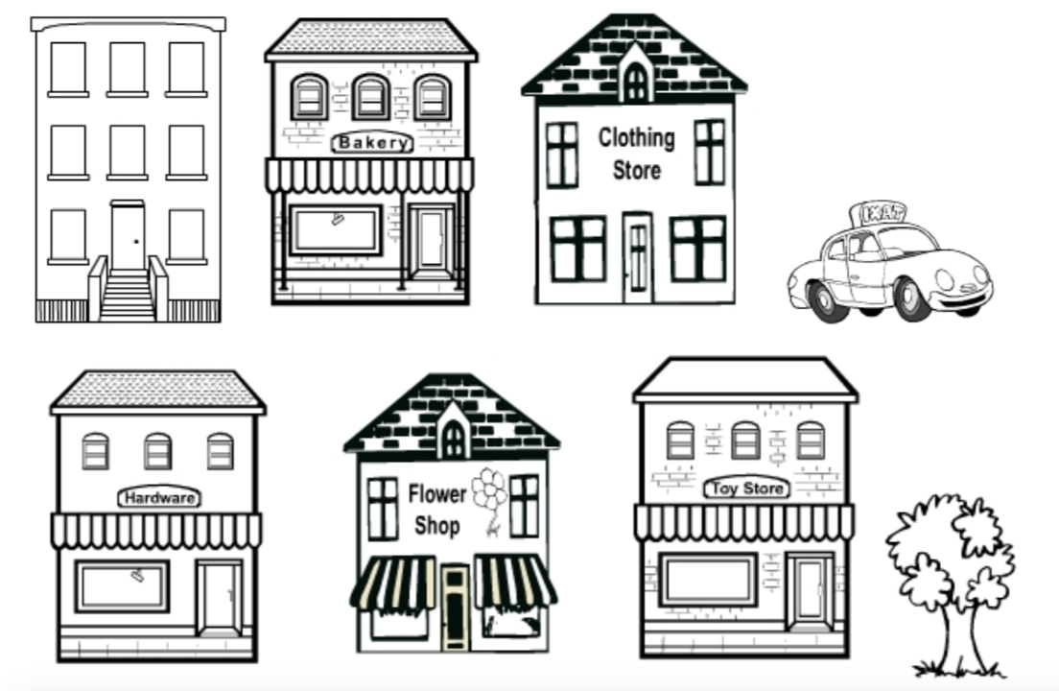

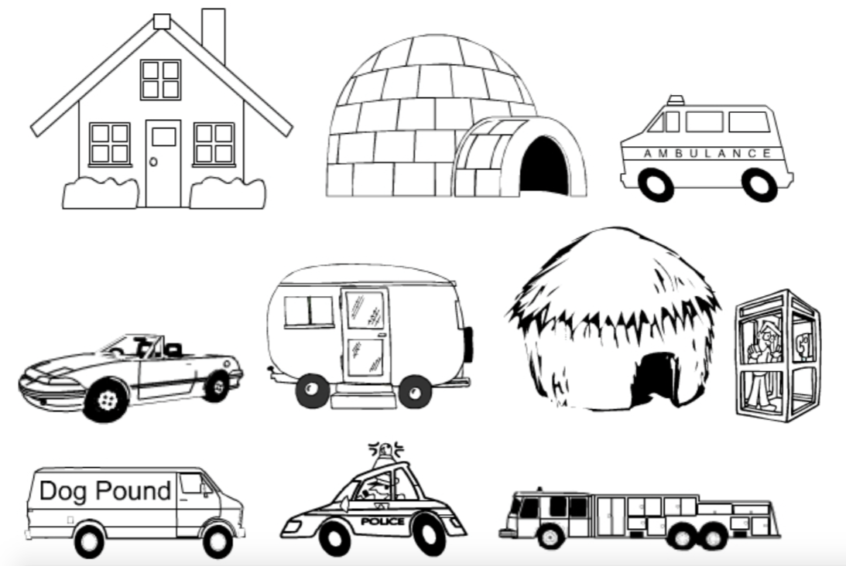

Assessment Task #4: Natural Resources
GRADE LEVEL: First Grade
UNIT: Limestone

Abstract

This task is designed to assess students’ knowledge of the availability of natural resources in the state and how they are used. Students will take pictures of limestone being used around the town. This activity encourages students to investigate the importance of natural resources and encourages them to protect the resources.

Prompt

An outline of the uses of limestone
Information on the availability of limestone in Indiana
Computer/iPad access to internet
Pictures from Indiana Memory that demonstrate the uses of limestone. https://digital.library.in.gov/Search/Results?lookfor=limestone&submit=
Map of limestone quarries in Indiana http://limestonesymposium.org/the-indiana-stone-belt

Directions

“We have been learning about the presence of natural resources around the state. Now look at some natural resources that are very close to our town. Investigate the limestone quarries that are located near us. The quarries are places where limestone is collected. After it is collected, limestone can be used to create many things seen around our town. Follow the directions and create a collage displaying the use of limestone around our town.”

Review the availability of natural resources and the importance of making sure the resources are preserved.
Go to the website: http://limestonesymposium.org/the-indiana-stone-belt and look at the map that shows the quarries that are near us.
Participate in a group discussion led by the teacher about what the students have interpreted from the source. Discuss how significant the number of quarries close to the town is
Look at pictures on Indiana Memory of the examples of how limestone is used.
Discuss your findings as a group and focus on the questions: *Have you ever seen limestone used around the town?
*What things can be made out of limestone?
As a class, we will go on a walk around downtown and take pictures that demonstrate the use of limestone.
After we get back, you will print out your pictures and create a collage of the different examples of limestone being used.
The collages will be featured at the local town hall.
After learning about the uses of limestone to create other things, you will explore some alternatives to limestone for production purposes. Examples include: concrete, wood, or granite. Do you believe that limestone is the best natural resource for building purposes? Choose the resource you believe is best and defend your opinion in a class discussion.

Procedure

The students learn about the availability and uses of limestone. The teacher then provides students with cameras and takes them on a walk through the downtown area. Students take pictures of examples of limestone being used around the town. Students create a collage with pictures.

Scoring Rubric

BENCHMARK | 1 | 2 | 3 | 4
Give examples of natural resources found locally and describe how people in the school and community use these resources. (1.3.9) | Collage has fewer than two examples.  Some of the examples do not demonstrate the use of limestone | Collage has 3 examples.  Pictures demonstrated three uses of limestone. | Collage has 4 examples.  Pictures demonstrated four uses of limestone. | Collage has five or more examples.  Each picture demonstrated an accurate example of how limestone is used around the town.

Assessment Task Four Materials

*Map of the quarries close to the town

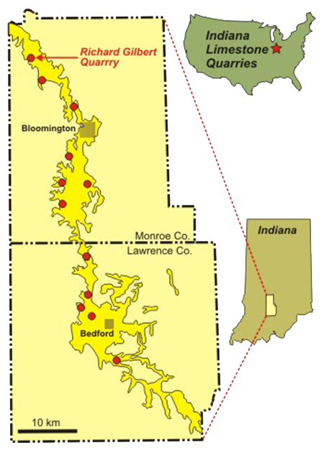
Examples of how limestone can be used
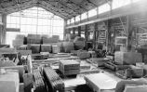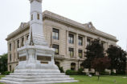
Assessment Task #5: Jobs
GRADE LEVEL: First Grade
UNIT: Limestone

Abstract

This task is designed to assess students’ understanding that each job is very unique and has different duties as well as different benefits. Students compare and contrast their dream job to a job in the limestone industry. This gives students a baseline understanding of the job world at a young age and that will prepare them for their future jobs.

Prompt

Computer/iPad access to internet
Pictures from primary source Indiana Memory that depict the limestone workers https://digital.library.in.gov/Search/Results?lookfor=limestone&submit=
Diagram tips http://www.missscreaigh.com/uploads/1/8/8/6/18860824/8582453_orig.png

Directions

“We have been learning about the presence of natural resources around the state. We will now look at the jobs that are created by the limestone industry.”
Choose your dream job that you wish to have when you are an adult.
Discuss your dream job with the class and listen to everyone else’s responses as well.
Search for different jobs related to the limestone industry.
Participate in a group discussion led by the teacher about the similarities and differences in each job.
Look at pictures on Indiana Memory of the workers in the factories and quarries. Discuss your findings as a group and focus on the questions:
*What jobs are involve the limestone industry?
*How are these jobs different from your dream job?
*How are these jobs similar to your dream job?
Look at the compare and contrast diagram.
Choose a specific job related to the limestone industry and create your own diagram and compare/ contrast the limestone job with your dream job.
After you have thought about the similarities and differences in the two jobs, write a couple sentences about which job you think is best and why.
The diagrams will be featured at the annual career fair located at the park.

Procedure

Students compare their dream job to a job in the limestone industry and share their findings with the class. Then, the students create a compare/contrast chart demonstrating the similarities and differences.

Scoring Rubric

BENCHMARK | 1 | 2 | 3 | 4
1.4.3 Compare and contrast different jobs people do to earn income. | Diagram has two bullet points in each category.  Student does no explain why they chose one job over the other. | Diagram has 3 bullet points in each category.  Student only explains either why they chose the job or why they did not choose the other. | Diagram has 4 bullet points in each category.  Student only explains either why they chose the job or why they did not choose the other. | Diagram has five or more bullet points in each category.  Student fully explains why they chose the particular job and why they did not choose the other.

Assessment Task 5 materials

Limestone workers
